COSC 3380
Name: ____Nicholas Moore__________ PS ID # _1390458__

Project 2: Implementation - SQL

(100 points)
(Due date found in the COSC 3380 Detailed Syllabus!)

1. 18 points
2. 40 points
3. 42 points

PLEASE ENTER YOUR GRADE IN THIS BOX & ALSO on the CHECK SHEET:
1. (18 points)OL

a. (13 points)
Using Project 1 Relations/Tables (including VIEWs) create them in the Oracle DBMS database. Create Project 2.sql that contains the Commented SQL commands.

In Project 2.doc run each CREATE TABLE and CREATE VIEW and take a screenshot of the commented command and its output and insert them in this document.
(NOTE: 9 TABLES and 6 VIEWS)
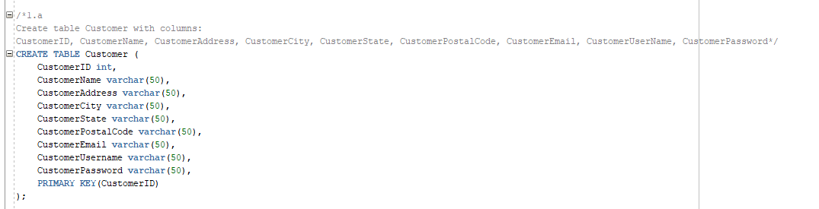
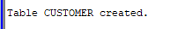
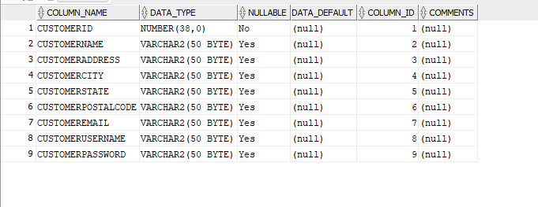

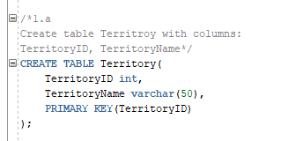
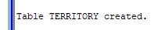
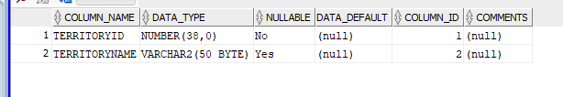

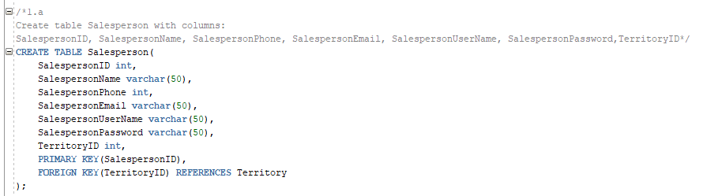
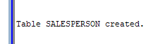
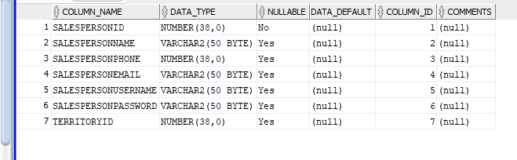

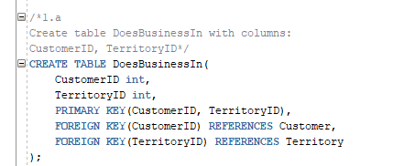

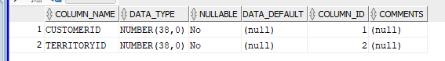

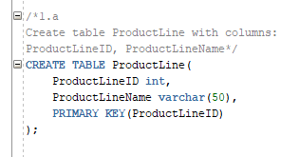
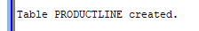
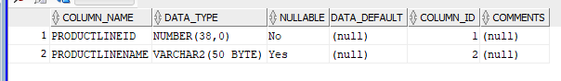

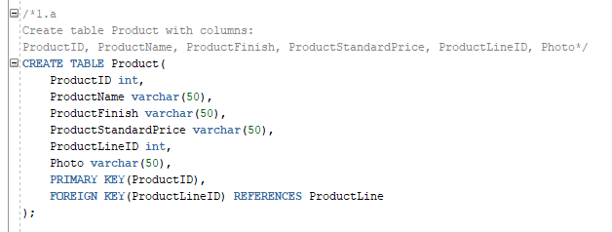
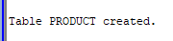
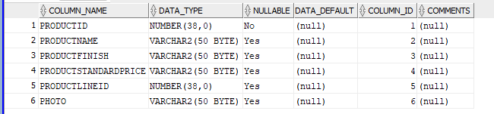

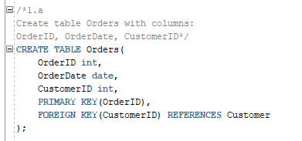
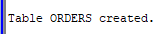
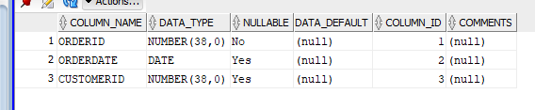

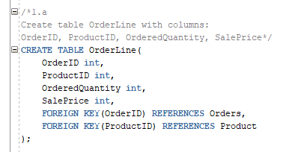
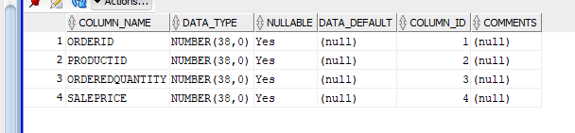

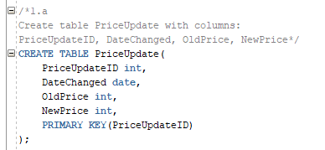
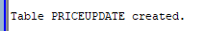
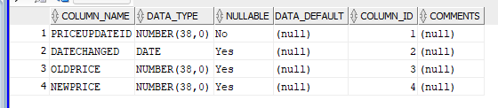

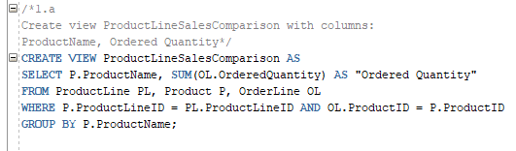
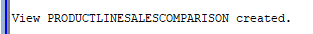

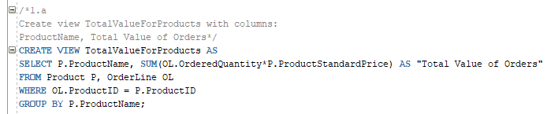
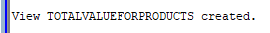
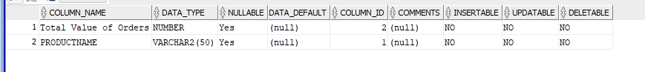
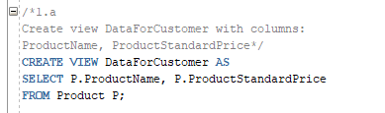
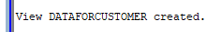

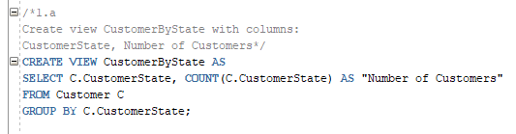

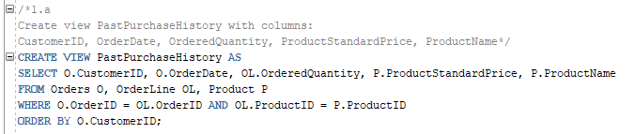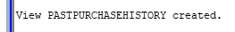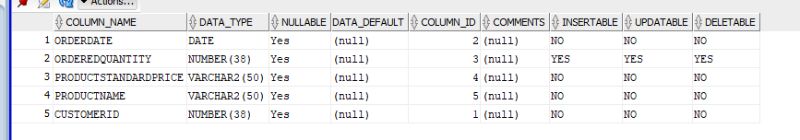

b. (5 points)
Request the Table Relationships Diagram for the Database and attach it in Project 2.doc (here).

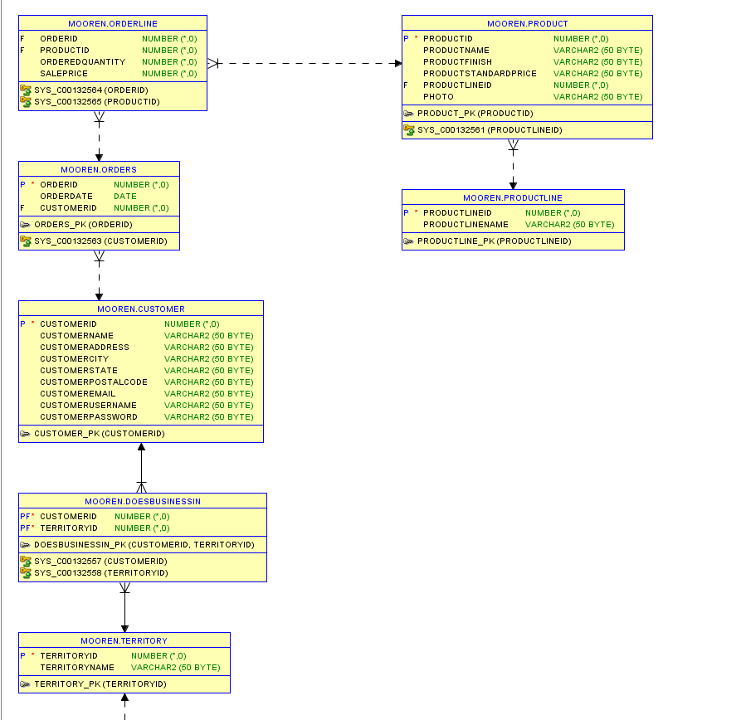
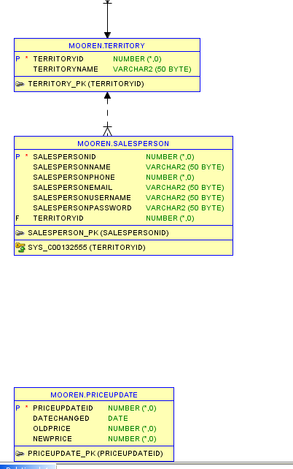
2. (40 points)

In Project 2.doc run each TABLE INSERTs commands and take a screenshot of the commented command and its output and insert them in this document.
(NOTE: 9 TABLE INSERTS)
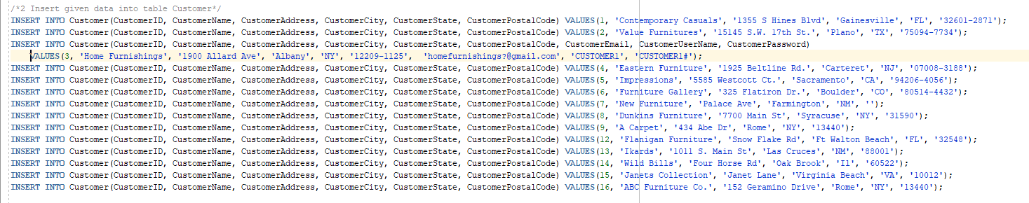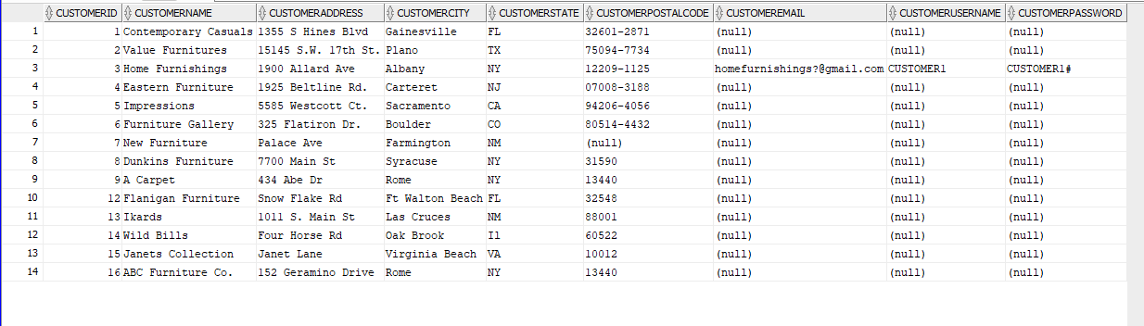

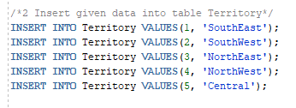
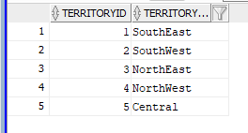

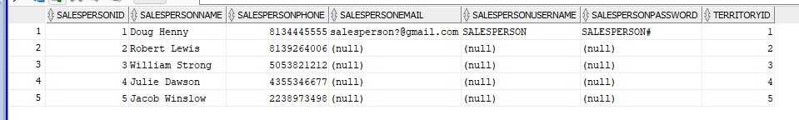

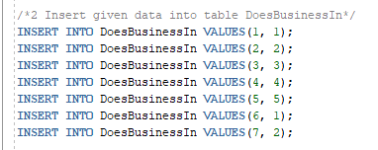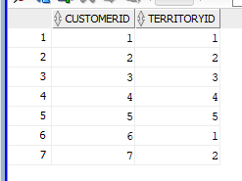

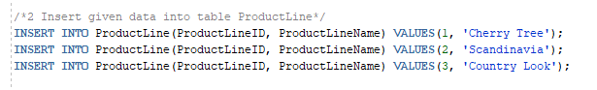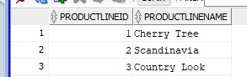

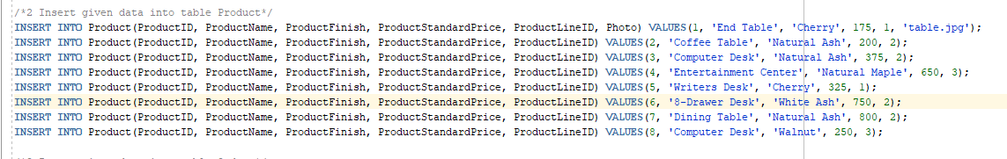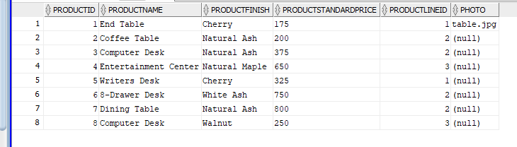

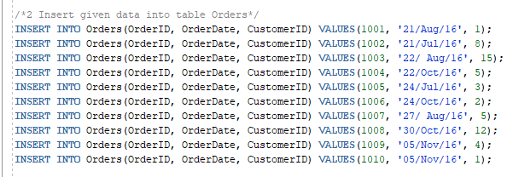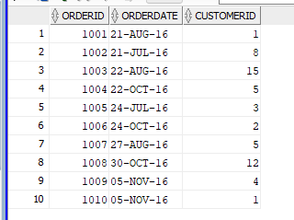

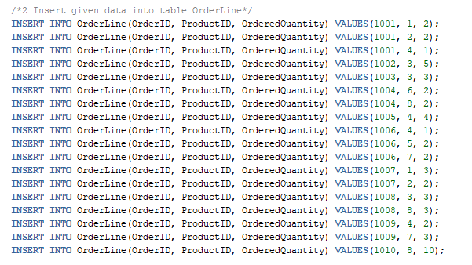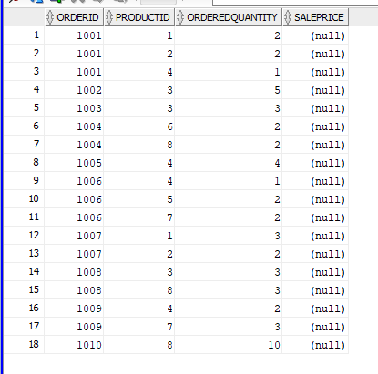

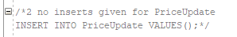
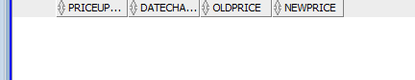

The Client has supplied the following data. Use SQL to insert these data in the Oracle DBMS database created in Project 1.

Customer
CustomerID, CustomerName, CustomerAddress, CustomerCity, CustomerState, CustomerPostalCode, CustomerEmail, CustomerUserName, CustomerPassword
1, 'Contemporary Casuals', '1355 S Hines Blvd', 'Gainesville', 'FL', '32601-2871'
2, 'Value Furnitures', '15145 S.W. 17th St.', 'Plano', 'TX', '75094-7734'
3, 'Home Furnishings', '1900 Allard Ave', 'Albany', 'NY', '12209-1125', ‘homefurnishings?@gmail.com’, ‘CUSTOMER1’, ‘CUSTOMER1#’
4, 'Eastern Furniture', '1925 Beltline Rd.', 'Carteret', 'NJ', '07008-3188'
5, 'Impressions', '5585 Westcott Ct.', 'Sacramento', 'CA', '94206-4056'
6, 'Furniture Gallery', '325 Flatiron Dr.', 'Boulder', 'CO', '80514-4432'
7, 'New Furniture', 'Palace Ave', 'Farmington', 'NM', ''
8, 'Dunkins Furniture', '7700 Main St', 'Syracuse', 'NY', '31590'
9, 'A Carpet', '434 Abe Dr', 'Rome', 'NY', '13440'
12, 'Flanigan Furniture', 'Snow Flake Rd', 'Ft Walton Beach', 'FL', '32548'
13, 'Ikards', '1011 S. Main St', 'Las Cruces', 'NM', '88001'
14, 'Wild Bills', 'Four Horse Rd', 'Oak Brook', 'Il', '60522'
15, 'Janet's Collection', 'Janet Lane', 'Virginia Beach', 'VA', '10012'
16, 'ABC Furniture Co.', '152 Geramino Drive', 'Rome', 'NY', '13440'
Salesperson
SalespersonID, SalespersonName, SalespersonPhone, SalespersonEmail, SalespersonUserName, SalespersonPassword,TerritoryID
1, 'Doug Henny', '8134445555', 'salesperson?@gmail.com', ‘SALESPERSON’, ‘SALESPERSON#’,1
2, 'Robert Lewis', '8139264006', '', '', '', 2
3, 'William Strong', '5053821212', '', '', '', 3
4, 'Julie Dawson', '4355346677', '', '', '', 4
5, 'Jacob Winslow', '2238973498', '', '', '', 5

Territory
TerritoryID, TerritoryName
1, 'SouthEast'
2, 'SouthWest'
3, 'NorthEast'
4, 'NorthWest'
5, 'Central'

DoesBusinessIn
CustomerID, TerritoryID
1, 1
2, 2
3, 3
4, 4
5, 5
6, 1
7, 2

Product
ProductID, ProductName, ProductFinish, ProductStandardPrice, ProductLineID, Photo
1, 'End Table', 'Cherry', 175, 1, table.jpg
2, 'Coffee Table', 'Natural Ash', 200, 2
3, 'Computer Desk', 'Natural Ash', 375, 2
4, 'Entertainment Center', 'Natural Maple', 650, 3
5, 'Writers Desk', 'Cherry', 325, 1
6, '8-Drawer Desk', 'White Ash', 750, 2
7, 'Dining Table', 'Natural Ash', 800, 2
8, 'Computer Desk', 'Walnut', 250, 3

ProductLine
ProductLineID, ProductLineName
1, 'Cherry Tree'
2, 'Scandinavia'
3, 'Country Look'
Order
OrderID, OrderDate, CustomerID
1001, '21/Aug/16', 1
1002, '21/Jul/16', 8
1003, '22/ Aug/16', 15
1004, '22/Oct/16', 5
1005, '24/Jul/16', 3
1006, '24/Oct/16', 2
1007, '27/ Aug/16', 5
1008, '30/Oct/16', 12
1009, '05/Nov/16', 4
1010, '05/Nov/16', 1

OrderLine
OrderID, ProductID, OrderedQuantity, SalePrice
1001, 1, 2
1001, 2, 2
1001, 4, 1
1002, 3, 5
1003, 3, 3
1004, 6, 2
1004, 8, 2
1005, 4, 4
1006, 4, 1
1006, 5, 2
1006, 7, 2
1007, 1, 3
1007, 2, 2
1008, 3, 3
1008, 8, 3
1009, 4, 2
1009, 7, 3
1010, 8, 10

PriceUpdate
PriceUpdateID, DateChanged, OldPrice, NewPrice

3. (42 points)

The Client wishes that you create the SQL code for the following queries (please make sure you SQL COMMENT each query and produce the screenshots for SQL COMMENT, SQL COMMAND, and SQL OUTPUT each, to be placed in Project 2.doc):

- (3 points)
Which products have a standard price of less than $ 275?

(Screenshot for SQL COMMENT, SQL COMMAND, and SQL OUTPUT, to be placed in Project2.doc)

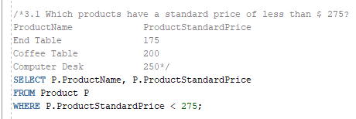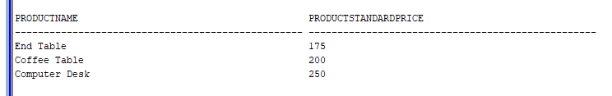

- (3 points)
List the unit price, product name, and product ID for all products in the Product table.

(Screenshot for SQL COMMENT, SQL COMMAND, and SQL OUTPUT, to be placed in Project2.doc)

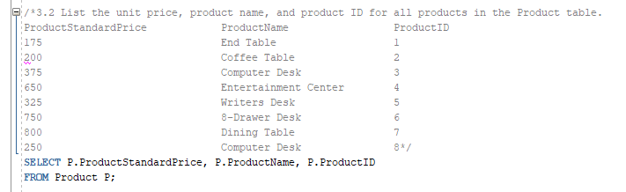
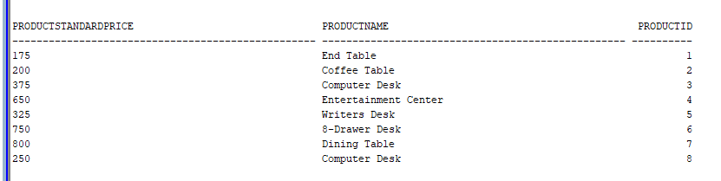

- (3 points)
What is the average standard price for all products in inventory?

(Screenshot for SQL COMMENT, SQL COMMAND, and SQL OUTPUT…..)

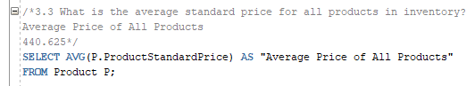
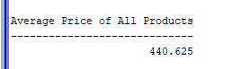

- (3 points)
How many different items were ordered on order number 1004?

(Screenshot for SQL COMMENT, SQL COMMAND, and SQL OUTPUT…..)

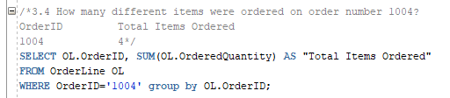
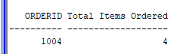

- (3 points)
Which orders have been placed since 10/ 24/ 2010?

(Screenshot of the SQL COMMAND, SQL STATEMENT, and SQL …..)

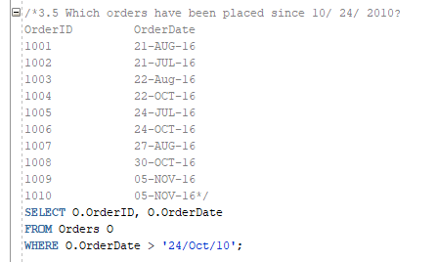
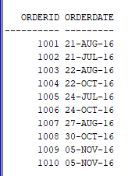

- (3 points)
What furniture does COSC3380 carry that isn’t made of cherry?

(Screenshot of the SQL COMMAND, SQL STATEMENT, and SQL OUTPUT …..)

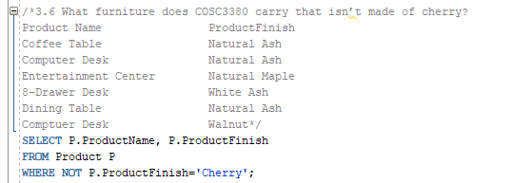
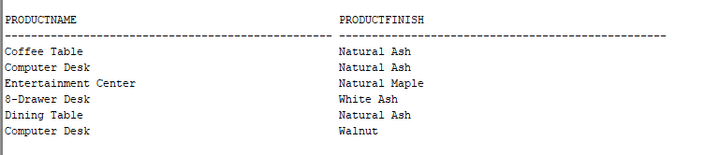

- (3 points)
List product name, finish, and standard price for all desks and all tables that cost more than $ 300 in the Product table.

(Screenshot of the SQL COMMAND, SQL STATEMENT, and SQL OUTPUT …..)

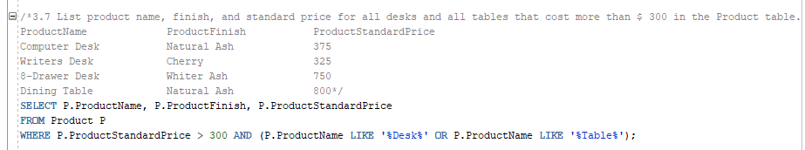
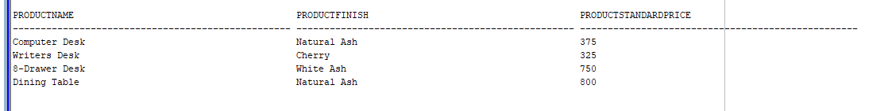

- (3 points)
Which products in the Product table have a standard price between $ 200 and $ 300?

(Screenshot of the SQL COMMAND, SQL STATEMENT, and SQL OUTPUT …..)

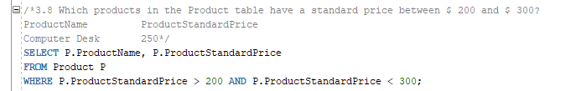
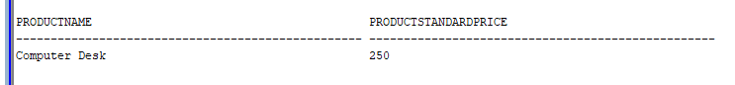

- (3 points)
List customer, city, and state for all customers in the Customer table whose address is Florida, Texas, California, or Hawaii. List the customers alphabetically by state and alphabetically by customer within each state.

(Screenshot of the SQL COMMAND, SQL STATEMENT, and SQL OUTPUT …..)

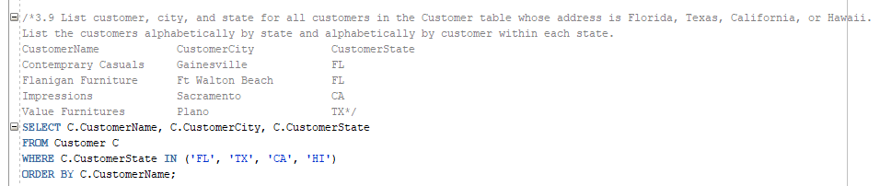
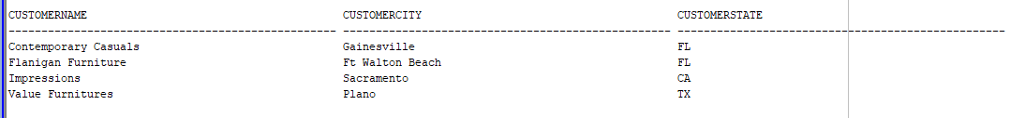

- (3 points)
Count the number of customers with addresses in each state to which we ship.

(Screenshot of the SQL COMMAND, SQL STATEMENT, and SQL OUTPUT …..)

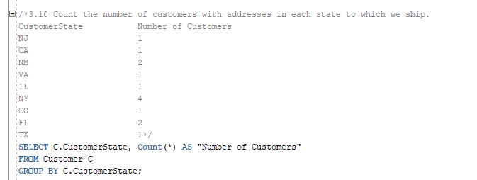
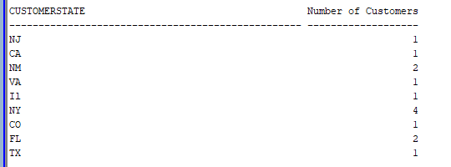

- (3 points)
Count the number of customers with addresses in each city to which we ship. List the cities by state.

(Screenshot of the SQL COMMAND, SQL STATEMENT, and SQL OUTPUT …..)

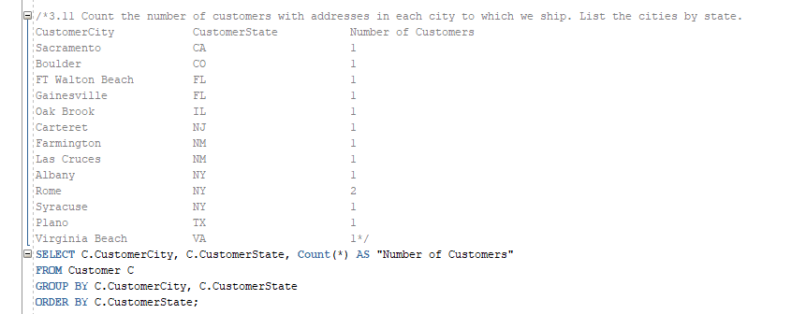
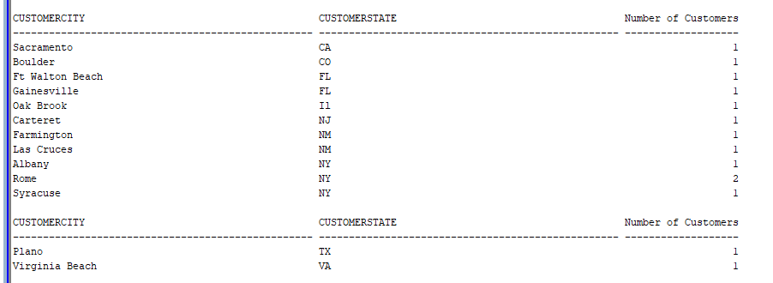

- (3 points)
Find only states with more than one customer.

(Screenshot of the SQL COMMAND, SQL STATEMENT, and SQL OUTPUT …..)

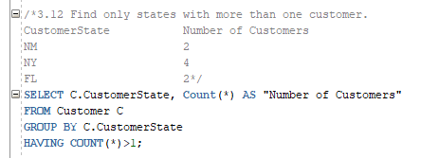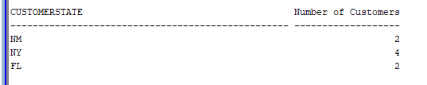

- (3 points)
List, in alphabetical order, the product finish and the average standard price for each finish for selected finishes having an average standard price less than 750.

(Screenshot of the SQL COMMAND, SQL STATEMENT, and SQL OUTPUT …..)

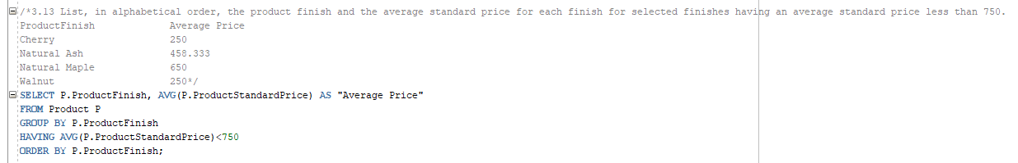
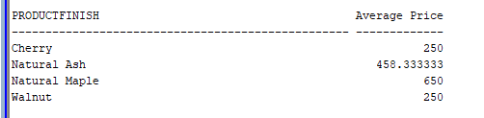

- (3 points)
What is the total value of orders placed for each furniture product?

(Screenshot of the SQL COMMAND, SQL STATEMENT, and SQL OUTPUT …..)

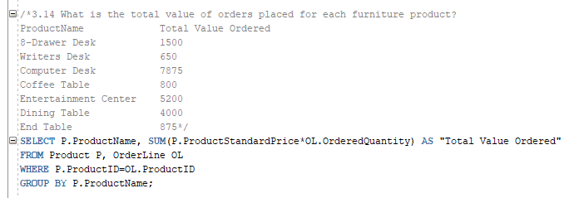
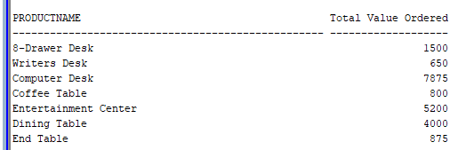
You need to turn in:
. The sql scripts with SQL COMMENTS for each query copied from this document and the expected output Project 2.sql.

Example:
# Q1 Which products have a standard price of less than $ 275?
# PRODUCTDESCRIPTION PRODUCTSTANDARDPRICE
# End Table 175
# Computer Desk 250
# Coffee Table 200

. The screenshots of SQL COMMENTS, SQL Oracle COMMANDS and the SQL OUTPUT in Project 2.doc. Please be paper efficient! (BOTH to BB and HARDCOPY)

Without Project 2.doc you will get ZERO!

Tips for the Projects:
- Prepare your SQL program using the Text editor such as Note Pad Project 2.sql.
- Copy and Paste your program from Project 2.sql to SQL*Plus command line.
- If the program works, save the program. Otherwise, fix the error for the program in Project 2.sql and try it again.
- Capture screenshots (CROP if needed) of the SQL COMMENTS, SQL COMMAND, and SQL OUTPUT and place them in Project 2.doc.
- Submit Project 2.sql that contains all your SQL COMMENTED SQL commands to BB.
- Submit Project 2.doc that contains all your screenshots to BB and HARDCOPY.
- Fill in the Cover Sheet and you are ready.

